CO5_AT1 Constraint-Based Problem Solving
Name: Lavanya
Regno: 192521271
Course name: Design and analysis of algorithms
Course code: CSA0613
Question 23
Title
Graph Partitioning Problem Using Backtracking
1. Objective
To partition a graph into two balanced subsets while minimizing the number of edges connecting vertices belonging to different subsets.
2. Problem Description
Graph partitioning divides the vertices of a graph into groups.
The objective is to minimize the number of cut edges while maintaining balanced partition sizes.
For two partitions:
$$P_{1}∪P_{2}=V$$
and
$$P_{1}∩P_{2}=∅$$
The number of edges connecting P1 and P2 is called the edge cut.
Algorithm
- Start with an empty partition.
- Select one vertex.
- Assign it to Partition A.
- Recursively assign the remaining vertices.
- Backtrack and assign the vertex to Partition B.
- Check the balance constraint.
- Calculate the number of cut edges.
- Store the partition with minimum cut.
- Apply pruning when a partition exceeds the allowed size.
Source Code:
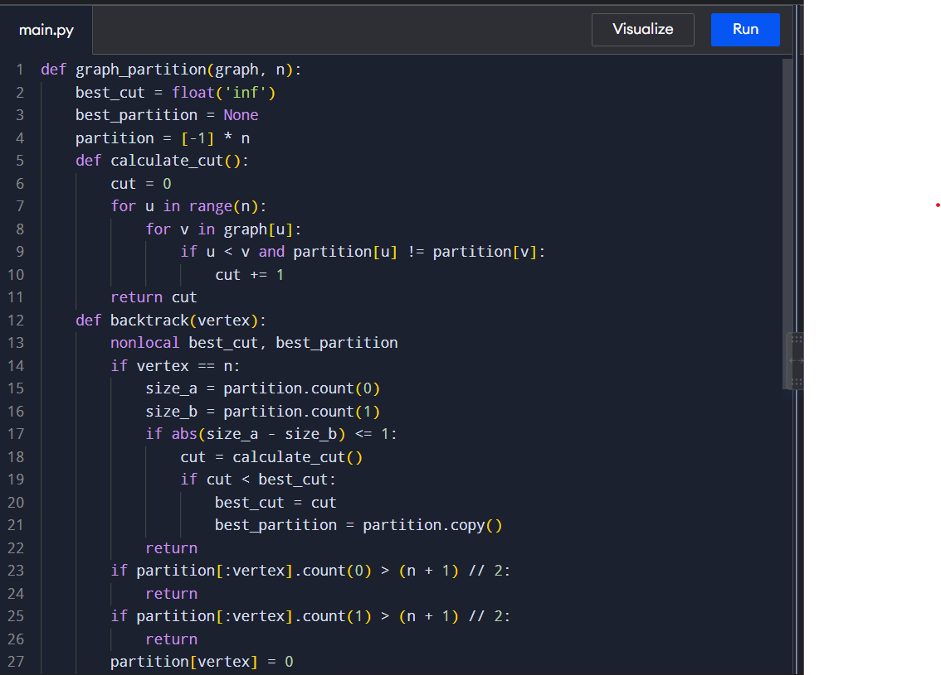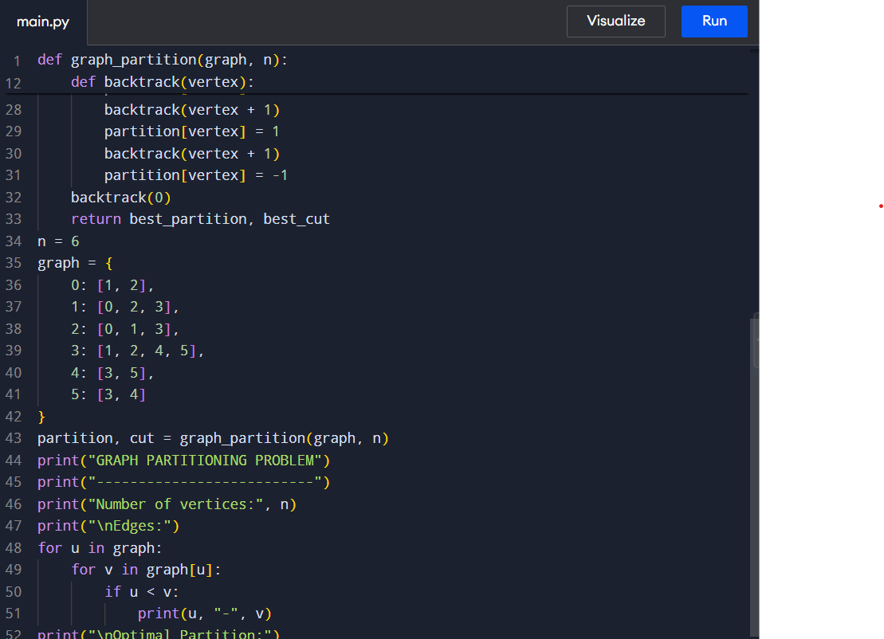
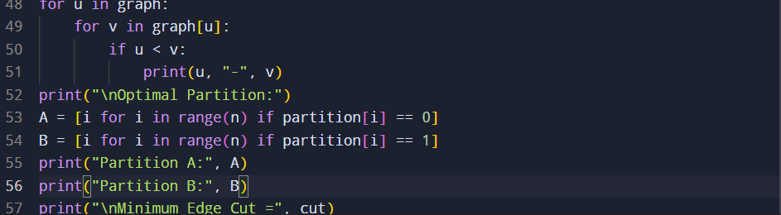

Input and Output:
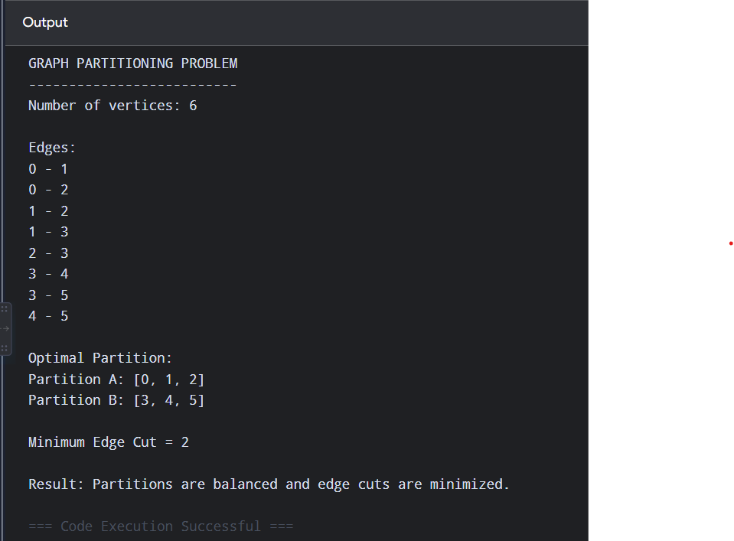
Complexity
For n vertices, each vertex has two possible partitions.
Therefore, the worst-case number of possibilities is:
$$2^{n}$$
Calculating the cut requires approximately:
$$O\left(E\right)$$
Thus, the worst-case complexity is approximately:
$$O\left(2^{n}E\right)$$
This demonstrates why graph partitioning becomes difficult for large graphs.
11. NP-Hard Complexity
The balanced graph partitioning problem is an NP-hard optimization problem.
As the number of vertices increases, the number of possible partitions grows exponentially.
Therefore, exact backtracking is practical mainly for small graphs.
For large graphs, heuristic methods such as:
- Kernighan–Lin
- Spectral partitioning
- Local search
- Multilevel partitioning
can be used.
Documentation
Project: Graph Partitioning Problem
Technique: Backtracking
The Graph Partitioning Problem divides the vertices of a graph into two balanced subsets while minimizing the number of edges between the subsets.
The algorithm uses backtracking to explore different assignments of vertices to the two partitions. A balance constraint ensures that both groups contain approximately the same number of vertices. Pruning is applied when a partition becomes larger than the allowed size.

